|  |  |
| --- | --- |
| **NAME** | Abdul Mateen, Arslan, Basit |
| **REG #:** | 2020-EE-399, 409, 401 |

EXPERIMENT NO 02:

Blinking LED using Switch

# Objective:

* Comprehension of switch functioning in Micro-controller.
* Able to write the code for switching led.

# Apparatus:

* TIVA C Board
* USB Cable
* PC
* ENERGIA IDE

# Theory:

TM4C123 micro-controller is a multi-functional device. Microcontroller on the board is basically a debugger that check the preciseness and correctness of program. If there is any error in code it is detected by debugger and alarming message comes to screen. In this lab we will use different peripherals of board to gain desired results. Board contain RGB led and user switches. There is also a reset key on board to reset the code. Here is simple circuit of RGB with switches that we will use in lab.

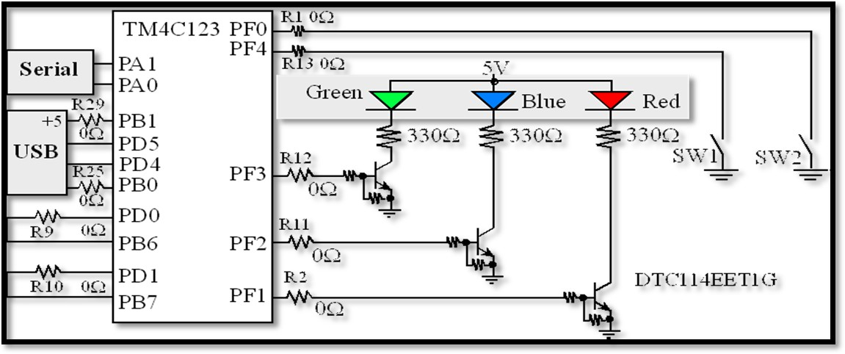

# Procedure:

*Figure 1RGB circuit with switches*

* Set up the experiment as shown in the figure 2.1.
* Connect TIVA C Board to PC using USB Cable.
* Now write code for blinking of led by using single switch.
* Then, upload this code to TIVA C Board.
* Repeat this experiment for different tasks.



# Lab Exercises:

*Figure 2Tiva tm4c123 Board*

**Task 1.1:** Blink single led by using switch.

**Code:**

int led = GREEN_LED;

int buttonpin = PUSH1;

void setup() {

// put your setup code here, to run once:

pinMode(led , OUTPUT);

pinMode(buttonpin , INPUT_PULLUP);

}

void loop() {

// put your main code here, to run repeatedly:

int button_state = digitalRead(buttonpin);

if (button_state == HIGH){

digitalWrite(led , LOW);

}

else {

digitalWrite(led , HIGH);

}

}

**Task 1.2:** Blink two led by using two separate switches.

int led = GREEN_LED;

int led_1 = RED_LED;

int buttonpin = PUSH1;

int buttonpin_1 = PUSH2;

void setup() {

// put your setup code here, to run once:

pinMode(led , OUTPUT);

pinMode(buttonpin , INPUT_PULLUP);

pinMode(led_1 , OUTPUT);

pinMode(buttonpin_1 , INPUT_PULLUP);

}

void loop() {

// put your main code here, to run repeatedly:

int button_state = digitalRead(buttonpin);

int button_state_1 = digitalRead(buttonpin_1);

if (button_state == HIGH){

digitalWrite(led , LOW);

}

else {

digitalWrite(led , HIGH);

}

if (button_state_1 == HIGH){

digitalWrite(led_1 , LOW);

}

else {

digitalWrite(led_1 , HIGH);

}

}

**Task 1.3:** Blink two led by using single switch (one after the other).

int led = GREEN_LED;

int led_1 = RED_LED;

int buttonpin = PUSH1;

void setup() {

// put your setup code here, to run once:

pinMode(led , OUTPUT);

pinMode(buttonpin , INPUT_PULLUP);

pinMode(led_1 , OUTPUT);

}

void loop() {

// put your main code here, to run repeatedly:

int button_state = digitalRead(buttonpin);

if (button_state == LOW){

digitalWrite(led , LOW);

digitalWrite(led_1 , HIGH);

delay(650);

digitalWrite(led , HIGH);

digitalWrite(led_1 , LOW);

delay(650);

}

if (button_state == HIGH){

digitalWrite(led , LOW);

digitalWrite(led_1 , LOW);

}

}

# Conclusion: